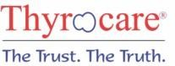

C-102, Mansarover Rd, Hanuman Nagar, Mansarover Colony, Moradabad 244001

**NAME REF. BY**

**TEST ASKED**

**:** DEEPIKA GUPTA (24Y/F)

**:** DR.PARMOD PATIL

**:** COVID-19

**HOME COLLECTION :**

C2/78 MANSAROVER COLONY, DELHI ROAD, MORADABAD-244001

**PATIENTID :** AS16046439

**TEST NAME RESULT**

# COVID-19 RT PCR

**Interpretation**

# NOT DETECTED

|  |  |
| --- | --- |
| NOT DETECTED | COVID-19 RNA was not detected in the patient specimen or less than detection limit |
| DETECTED | COVID-19 RNA was detected in the patient specimen |
| INCONCLUSIVE | Target is inconclusive, Advised to send fresh specimen for recheck |

**ICMR Registration No** THYRO535

The performance of this test has been validated & evaluated by National Institute of Virology/ICMR.

**Indications**

COVID-19 is an infectious disease caused by the virus strain "severe acute respiratory syndrome coronavirus 2" (SARS-CoV-2), Common signs of infection include respiratory symptoms,fever,cough,shortness of breath and breathing difficulties.

In more severe cases,infection can causes pneumonia ,severe acture respiratory syndrome and kidney failure.

**Methodology**

COVID19 detection by polymerase chain reaction (PCR) is based on the amplification of specific regions of the SARS-CoV-2 . In real Time PCR the amplified product is detected via fluorescent dyes.

**Clinical Significance**

Detection of COVID-19 RNA in patients with COVID-19 infection.

**Limitation of the assay**

1. Presence of PCR inhibitors may interfere with PCR amplification.
2. Undetected result does not rule out the possibility of infection.Presence of inhibitors,mutations & insufficient organism RNA can influence the result.

**Disclaimer**

1.This test is intended for use in conjunction with clinical presentation and other laboratory markers. 2.Improper specimen collection, handling, storage and transportation may results in false negative results. 3.The report represents only the specimen received in laboratory.

**~~ End of report ~~**

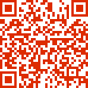**Sample Collected on (SCT) Sample Received on (SRT) Report Released on (RRT) Sample Type**

**Labcode Barcode**

**:** 04 Apr 2021 12:55

**:** 04 Apr 2021 23:51

**:** 05 Apr 2021 05:21

**:** SWABS

**:** 2203004398/CO106

**:** U0716953



# Dr. Chaitali Nikam,Ph.D Dr.Caesar Sengupta MD(Micro)

Page : 1 of 3

|  |
| --- |
| **CUSTOMER DETAILS**  **As declared in our data base** |
| **Name:** DEEPIKA GUPTA **Age:** 24Y **Sex:** F **Mobile No:** 7017049047 |
| **Barcodes/Sample_Type :** U0716953 (SWABS)  **Labcode :** 2203004398  **Ref By :** DR.PARMOD PATIL  **Sample_Type/Tests :** SWABS:COVID-19  **Sample Collected At** : C2/78 MANSAROVER COLONY, DELHI ROAD  MORADABAD-244001  **Sample Collected on (SCT) :** 04 Apr 2022 12:55  **Report Released on (RRT) :** 05 Apr 2022 05:21 |
| **C-102, Mansarover Rd, Mansarover Colony 244001. | Phone:022 - 67123000** [**|www.thyrocare.com |**](http://www.thyrocare.com/) [**info@thyrocare.com**](mailto:info@thyrocare.com) |

CONDITIONS OF REPORTING

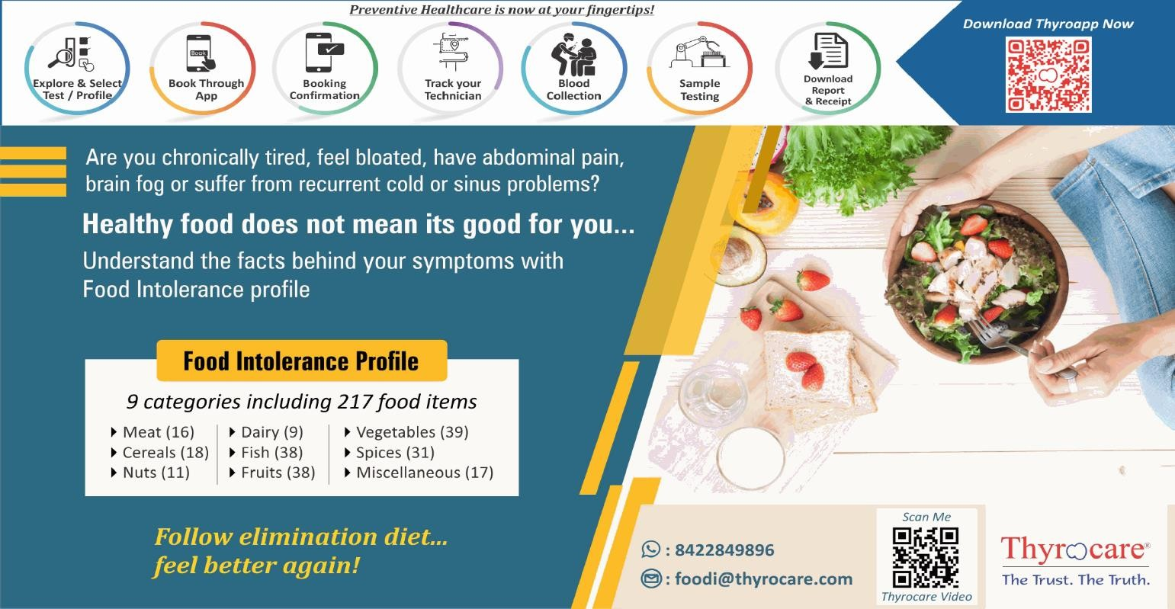

v The reported results are for information and interpretation of the referring doctor only.

v It is presumed that the tests performed on the specimen belong to the patient; named or identified.

v Results of tests may vary from laboratory to laboratory and also in some parameters from time to time for the same patient.

v Should the results indicate an unexpected abnormality, the same should be reconfirmed.

v Only such medical professionals who understand reporting units, reference ranges and limitations of technologies should interpret results.

v This report is not valid for medico-legal purpose.

v Neither Thyrocare, nor its employees/representatives assume any liability, responsibility for any loss or damage that may be incurred by any person as a result of presuming the meaning or contents of the report.

v Thyrocare Discovery video link :- https://youtu.be/nbdYeRgYyQc

v For clinical support please contact @8450950841,8450950842,8450950843,8450950844 between 10:00 to 18:00

EXPLANATIONS

v Majority of the specimen processed in the laboratory are collected by Pathologists and Hospitals we call them as "Clients".

v **Name** - The name is as declared by the client and recored by the personnel who collected the specimen. v **Ref.Dr** - The name of the doctor who has recommended testing as declared by the client.

v **Labcode** - This is the accession number in our laboratory and it helps us in archiving and retrieving the data. v **Barcode** - This is the specimen identity number and it states that the results are for the specimen bearing

the barcode (irrespective of the name).

v **SCP** - Specimen Collection Point - This is the location where the blood or specimen was collected as declared by the client.

v **SCT** - Specimen Collection Time - The time when specimen was collected as declared by the client. v **SRT** - Specimen Receiving Time - This time when the specimen reached our laboratory.

v **RRT** - Report Releasing Time - The time when our pathologist has released the values for Reporting. v **Reference Range** - Means the range of values in which 95% of the normal population would fall.

SUGGESTIONS

v Values out of reference range requires reconfirmation before starting any medical treatment. v Retesting is needed if you suspect any quality shortcomings.

v Testing or retesting should be done in accredited laboratories.

v For suggestions, complaints or feedback, write to us at [**info@thyrocare.com**](mailto:info@thyrocare.com) or call us on

**022-3099 0000 / 6712 3000**

v SMS:<Labcode No.> to **9870663333**